MINISTRY OF EDUCATION & TRAINING
VAN LANG UNIVERSITY
DEPARTMENT OF MECHANICAL – ELECTRICAL
AND COMPUTER ENGINEERING


DOCUMENTATION OF SOFTWARE ARCHITECTURE
SOFTWARE DESIGN SPECIFICATION


April 30, 2024
Table of Contents

I. ARCHITECTURAL DRIVERS 4
1. FUNCTIONAL REQUIREMENTS 4
1.1 SPECIFICATION 4
1.2 USECASE MODELING 4
2. QUALITY ATTRIBUTE REQUIREMENTS 7
3. CONSTRAINTS 8
3.1 TECHNICAL CONSTRAINTS 8
3.2 BUSINESS CONSTRAINTS 9
II. Architectural Patterns 9
III. QUALITY ATTRIBUTE TACTICS 11
IV. Architectural Structure 14
1. STATIC VIEWS 14
1.1 ELEMENT CATALOG OF STATIC VIEWS 14
1.2 RELATIONSHIP CATALOG OF STATIC VIEWS 16
2. DYNAMIC VIEWS 17
2.1 ELEMENT CATALOG OF DYNAMIC VIEWS 18
2.2 RELATIONSHIP CATALOG OF DYNAMIC VIEWS 18
3. PHYSICAL VIEWS 20
3.1 ELEMENT CATALOG OF PHYSICAL VIEWS 21
3.2 RELATIONSHIP CATALOG OF PHYSICAL VIEWS 22
3.3 RATIONALE FOR PHYSICAL VIEWS 22
V. Software Architecture 24
1. MODULE VIEWS 24
1.1. Module: Management UI 25
1.2. Module: Flights Management 25
1.3. Module: Booking UI 25
1.4. Module: Booking Management 25
1.5. Module: Payment System 26
1.6. Module: Notification System 26
2. C&C (Component & Connector) VIEWS 27
2.1. Management UI: 28
2.2. Flight Management: 28
2.3. Booking UI: 28
2.4. Booking Management: 28
2.5. Payment Processing: 28
2.6. Notification System: 28
3. ALLOCATION VIEWS 29
3.1. Software Environment: 30
3.2. Hardware Environment: 31
3.3. Workflows: 31
VI. SOFTWARE DESIGN 32
1. Methodology 32
2. Method 33
3. Process 34
4. Detail Design 36
4.1. Login/Signup 36
4.2. Change Account Information, Change Password 37
4.3. Search, Booking, Payment, History Booked & Refund Flight 39
4.4. Manage Flights 42
4.5. Manage Airlines 45
4.6. Manage Booked Flights 48
5. System Design: 49
5.1 Customer system 49
5.2 Admin system 50

I. ARCHITECTURAL DRIVERS

1. FUNCTIONAL REQUIREMENTS

1.1 SPECIFICATION
REFERENCES: Section 2 #SRS

1.2 USECASE MODELING

Domain Object | Description
Use case | Use cases of the system including:  - Book flight: Users can select a flight from the search results and proceed to book it by providing passenger details and making payment.  - Search flight: Users can search for available flights based on their preferred criteria.  - Manage booked flights: Users can view and manage their booked flights.  - Managing flights: Admins have access to a dashboard where they can manage flights.  - Managing account: Users have access to a dashboard where they can manage user accounts.
Enity | Main entities in the system such as:  - Flight: Represents a scheduled flight with details such as airline, departure time, arrival time, …  - User: Represents individuals using the booking website.  - Booking: Represents a user's booking record containing details of the booked flight, passenger information and payment status.  - Payment: Represents payment information associated with a booking, including payment method and transaction details.
Quality Attribute | Accuracy: Ensuring that information about flights and booking history is always accurate.  Scalability: The system should be capable of handling increasing numbers of users and flights without degradation in performance.  Performance: The website should have fast response times for search queries and booking transactions to enhance user experience.  Reliability: The system should reliably display accurate flight information and process bookings without errors or inconsistencies.  Usability: The website should be user-friendly, with intuitive navigation and clear instructions for booking flights.  Security: The system should ensure secure transmission and storage of user data, including personal and payment information.  Compatibility: The website should be compatible with various devices, operating systems, and web browsers to reach a wider audience and provide a consistent experience across different platforms.  Flexibility: The system should be flexible enough to accommodate changes in flight schedules, pricing strategies, and user preferences without significant disruptions to the user experience.
Business Constraints | Regulatory Compliance: The website must comply with aviation regulations and data protection laws.  Availability of Flights: The availability of flights depends on the schedules provided by airlines and may vary based on factors such as demand and seasonality.  Fair Pricing: The pricing of flights should be transparent and competitive, without hidden fees or discriminatory practices.
Technical Constraints | Data Storage and Retrieval: The system must efficiently store and retrieve flight, booking, and user data to ensure optimal performance.  Cross-Browser Compatibility: The website should be compatible with popular web browsers to reach a wider audience.  Responsive Design: The website should be responsive and accessible on various devices, including desktops, laptops, tablets, and smartphones.
Table 1. Domain Model

2. QUALITY ATTRIBUTE REQUIREMENTS

ID | Quality | Attribute | Description
QAR001 | Performance | Response Time | The website should have fast response times, ensuring that users can search for flights, view options, and complete bookings swiftly to enhance user experience and satisfaction.
QAR002 | Reliability | Availability | The website should be available 24/7 with minimal downtime to ensure that users can access flight information and make bookings at any time without disruptions.
QAR003 | Security | Data Protection | The website should employ robust security measures to protect users' personal and financial information, including secure encryption protocols for transactions and compliance with relevant data protection regulations.
QAR004 | Usability | Intuitiveness | The website should have a user-friendly interface with intuitive navigation, clear layout, and easy-to-use booking process, catering to users of varying technical proficiency and ensuring a smooth booking experience.
QAR005 | Scalability | Concurrent Users Handling | The website should be able to handle a large number of concurrent users during peak times without performance degradation or system crashes, ensuring consistent availability and responsiveness.
QAR006 | Compatibility | Cross-Browser Support | The website should be compatible with major web browsers (e.g., Chrome, Firefox, Safari) and devices (e.g., desktops, tablets, smartphones), ensuring a consistent experience across different platforms.
QAR007 | Performance | Load Time | The website should have optimized load times for pages and content, minimizing waiting times for users and improving overall user satisfaction and engagement.
QAR008 | Flexibility | Customization Options | The website should offer customization options for users, such as filters for search results and personalized notifications, enhancing user control and satisfaction.
QAR009 | Reliability | Transaction Integrity | The website should ensure transaction integrity, including accurate booking information and reliable payment processing, to instill trust and confidence in users.
QAR010 | Performance | Search Efficiency | The website's search functionality should be fast and efficient, allowing users to quickly find relevant flight options based on their preferences, dates, and destinations, enhancing user satisfaction and conversion rates.
QAR011 | Accuracy | Flight Information Reliability | The website should ensure the accuracy and reliability of flight information, including schedules, availability, and pricing, by integrating with reliable data sources and updating information in real-time, avoiding confusion and disappointment for users.
Table 2. Quality Attribute

3. CONSTRAINTS

3.1 TECHNICAL CONSTRAINTS
Consideration | Technical Constraint
Language | HTML, CSS, Javascript, PHP
Frame work | PHP, Bootstrap
Database | phpMyAdmin
Libary | Font AweSome, Google Font, jQuery
Tools and Methods | VsCode, xampp
Browser | Chrome, Microsoft Edge, Safari
Table 3. Technical Constraints

3.2 BUSINESS CONSTRAINTS
Business contraint | Constraint Description
Time | The project was developed within 1 months
Resource | 3 project development members
Table 4. Business Constraints

II. Architectural Patterns

ID | Name pattern | Description
AP-1 | Model – View – Controller (MVC) Pattern | This pattern divides the flight booking application into three distinct layers: the Model layer responsible for managing flight data and business logic, the View layer handling user interface presentation and the Controller layer orchestrating interactions between the Model and View.
AP-2 | Flight Cache Pattern | Optimizes the booking system by storing frequently accessed flight information, such as airline routes, ticket availability, and fare details, in a cache. By reducing database queries and improving data retrieval speed, this pattern enhances the overall responsiveness and user experience of the flight booking website.
AP-3 | Flight Reservation Singleton Pattern | Ensures that only one instance of the booking session manager exists throughout the flight reservation process. This pattern facilitates efficient management of booking sessions, prevents data inconsistencies, and enhances the reliability of the booking system, particularly during high traffic periods.
AP-4 | Asynchronous Booking Processing Pattern | Allows to process reservation requests concurrently. By handling multiple booking requests simultaneously, the system improves throughput, reduces latency, and provides a seamless booking experience for users, even during peak booking periods.
AP-5 | Asynchronous Payment Processing Pattern | Enables to process payment transactions asynchronously, allowing users to receive reservation confirmations swiftly without waiting for payment processing to complete. By decoupling payment processing from the booking flow, this pattern improves user satisfaction, reduces booking abandonment rates, and enhances the efficiency of the reservation process.
AP-6 | Dynamic Load Balancing | Optimizes resource allocation by dynamically distributing incoming flight booking requests across multiple servers based on real-time server performance metrics, such as CPU usage and memory utilization. This pattern ensures optimal utilization of server resources, minimizes response times, and enhances the scalability and reliability of the flight booking website.
Table 5. Architectural Patterns

III. QUALITY ATTRIBUTE TACTICS

Quality attribute | Tactic | Description
Accuracy | Validation Checks | Implement thorough validation checks for user inputs, ensuring accurate data entry.
 | Error Logging and Monitoring | Implement robust error logging and monitoring systems to quickly identify inaccuracies and rectify them, minimizing the impact on users.
Scalability | Horizontal Scaling | Allows for horizontal scaling to accommodate varying levels of traffic and booking demands.
 | Load Balancing | Employ load balancing techniques to distribute incoming traffic evenly across multiple servers, preventing overload and ensuring consistent performance.
 | Caching Mechanisms | Implement caching mechanisms for frequently accessed data, reducing server load and improving response times during peak periods.
Performance | Database Optimization | Analyze and optimize database queries to minimize processing time.
 | Code Optimization | Regularly review and optimize code to eliminate bottlenecks and improve efficiency.
 | Asynchronous Processing | Employ asynchronous processing for non-critical tasks such as email notifications and background tasks, freeing up server resources and improving responsiveness.
Reliability | Monitoring and Alerting | Implement robust monitoring and alerting systems to proactively identify issues and initiate corrective actions before they impact users.
 | Redundant Systems | Implement redundant systems for critical components such as payment gateways and booking engines to ensure uninterrupted service in case of failures.
Usability | Intuitive User Interface | Design a user-friendly interface with clear navigation and intuitive controls for searching, filtering, and booking flights.
 | Personalization Features | Incorporate personalization features such booked history.
 | Clear Documentation | Maintain clear and up-to-date documentation for the system architecture, design patterns, and code.
Security | Data Encryption | Encrypt sensitive data at rest and in transit.
 | Regular Security Audits | Conduct regular security audits and vulnerability assessments to identify and address potential security vulnerabilities before they can be exploited.
 | Two-Factor Authentication | Offer two-factor authentication as an additional layer of security for user accounts, reducing the risk of unauthorized access.
Compatibility | Multi-Device Compatibility | Optimize the website for compatibility across various devices and screen sizes, including desktops, laptops, tablets, and smartphones.
 | Cross-Browser Compatibility | Ensure compatibility with major web browsers to provide a consistent user experience across different platforms.
 | Standards Compliance | Adhere to web standards (e.g., HTML5, CSS3) and industry best practices to ensure compatibility with a wide range of devices and platforms.
Flexibility | Configuration Options | Provide users with configurable options for customizing their booking preferences.
 | API-driven Development | Expose APIs for key functionalities such as flight search, booking, and payment processing to enable integration with external systems and facilitate custom development.

Table 6. Quality Attribute tactics

IV. Architectural Structure

STATIC VIEWS

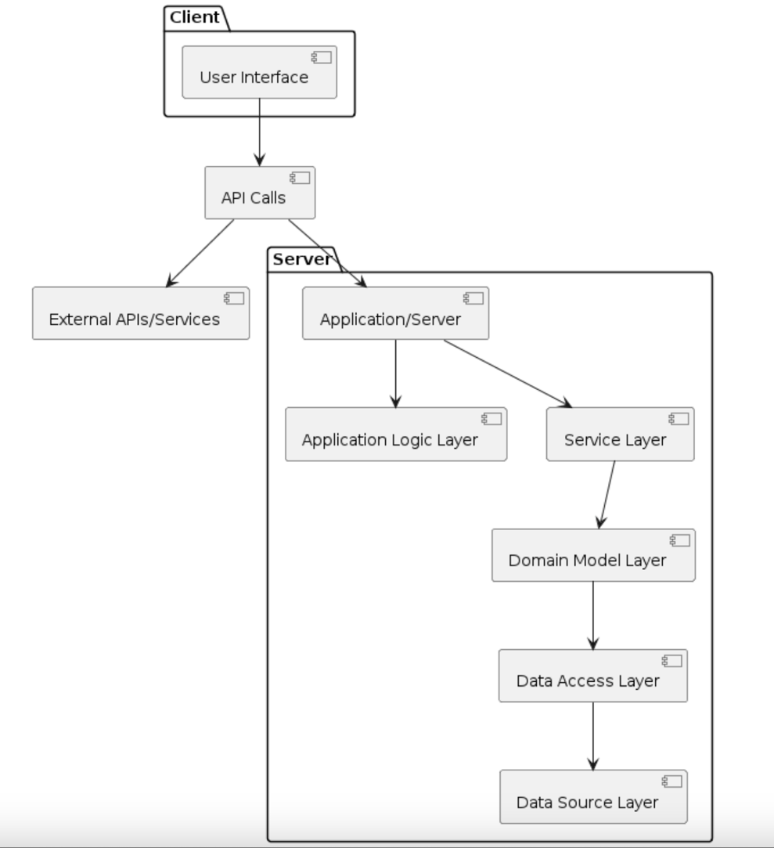
Table 7. Static perspective

1.1 ELEMENT CATALOG OF STATIC VIEWS
ID | Element | Responsibility
SV-01 | User Interface | Formats data for display to the user:  - List of flights, flights information, images, prices, booked flights.  - Payment, booking confirmation.  - Account management interface, booked history.
SV-02 | API Calls | Interface between the user interface or external services and the application/server.
SV-03 | External APIs/Services | Represents the external systems, services, or APIs that the application interacts with.
SV-04 | Application/Server | Acts as the main application server, handling requests from clients and coordinating the system's operations.
SV-05 | Application Logic Layer | Contains the application logic, which defines how it works:  - Rules for booking flights and payments.  - Handling special cases and errors.
SV-06 | Service Layer | Handles user requests and performs operations:  - Search for flights by criteria.  - Book a flight, make payments, cancel bookings.  - Manage accounts, booked history.  - Send notifications to users and airlines.
SV-07 | Domain Model Layer | Describes the objects and relationships in the system:  - Flights, information, price, seat.  - Customers’ accounts, booked history.  - Booking, status, payment.
SV-08 | Data Access Layer | Accesses and manipulates data in the database:  - Stores information about flights, customers, airlines and booked.  - Updates booking flight and payment statuses.  - Retrieve data for other functions.
SV-09 | Data Source Layer | Stores the website's data:  - phpMyAdmin database. Ensures data security, integrity and availability.
Table 8. Element Catalog of Static perspective

1.2 RELATIONSHIP CATALOG OF STATIC VIEWS

Relationship | Responsibility
SV-01 interact SV-02 | SV-01 interacts with SV-02 to send requests and receive responses from the system.
SV-02 interact SV-03 | SV-02 communicates with SV-03 to exchange data or request specific functionalities provided by external systems or services.
SV-02 interact SV-04 | SV-02 sends requests to SV-04 to access the system's functionalities and services.
SV-04 interact SV-05 | SV-04 interact SV-05 to delegate processing tasks and orchestrate the system's operations.
SV-04 interact SV-06 | SV-04 component utilizes services provided by SV-05 to implement specific business functionalities or perform tasks.
SV-06 interact SV-07 | SV-06 interacts with SV-07 to access and manipulate domain entities and apply business logic to the data.
SV-07 interact SV-08 | SV-07 interacts with SV-08 to perform CRUD (Create, Read, Update, Delete) operations on the underlying data sources while encapsulating domain-specific logic.
SV-08 interact SV-09 | SV-08 communicates with SV-09 to retrieve or update data from physical data sources such as databases, files, or external APIs.

DYNAMIC VIEWS

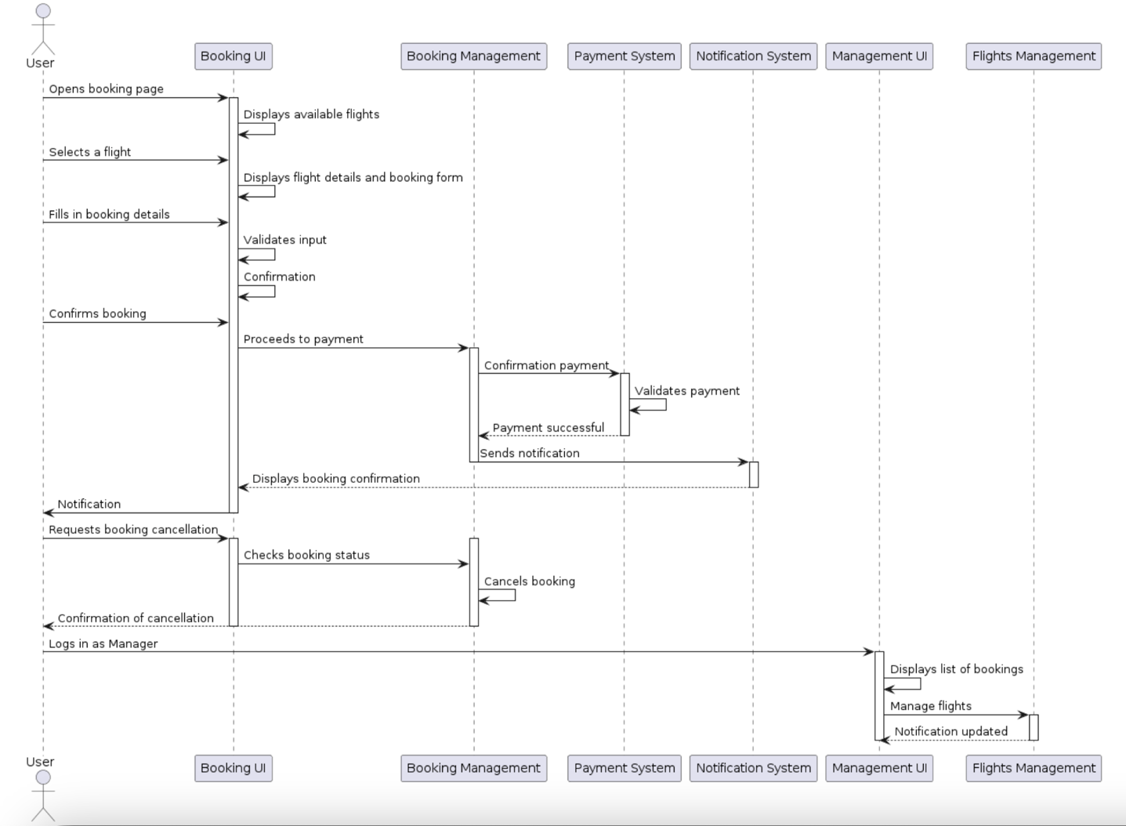

2.1 ELEMENT CATALOG OF DYNAMIC VIEWS

ID | Element | Responsibility
DV-01 | User management | Manages user accounts, including registration, login and details booked history.
DV-02 | Searching | Handles user searches to find available flights.
DV-03 | Booking | Facilitates the booking process by collecting necessary information from the user.
DV-04 | Payment gateway | Processes payments securely and efficiently for completed bookings through integrated payment providers.
DV-05 | Canceling | Allow user to send canceling flight request.
DV-06 | Flight Management | Manages specific flights within the booking system.  - Manage flights: Provides functionality to add, edit or remove flights related to booking information.  - Field Updates: Handles updates to booking fields, ensuring data accuracy and integrity.

2.2 RELATIONSHIP CATALOG OF DYNAMIC VIEWS

Relationship | Responsibility
DV-01 to DV-02 | Handles user accounts, including registration and login. Requires user authentication to access personalized information or preferences.
DV-01 to DV-03 | Booking relies on user authentication and user-specific information to facilitate reservations.
DV-03 to DV-04 | Once a user completes the booking process by providing necessary information, the payment gateway is engaged to process the payment securely and complete the booking transaction.
DV-03 to DV-05 | Canceling is directly tied to the booking process, as it involves accessing and modifying booking information.
DV-06 to DV-03 and DV-05 | Flight management's ability to add, edit, or remove flights impacts the availability of flights that users have booked.
DV-06 to DV-04 | While flight management primarily deals with the operational aspects of flights within the system, changes made to flight schedules or availability may indirectly affect the payment process if a user is during making a booking.
DV-06 to DV-02 | Flight management influences the availability of flights that users can search for. Changes made to flight schedules or availability impact the search results presented to users when they search for available flights.

3. PHYSICAL VIEWS

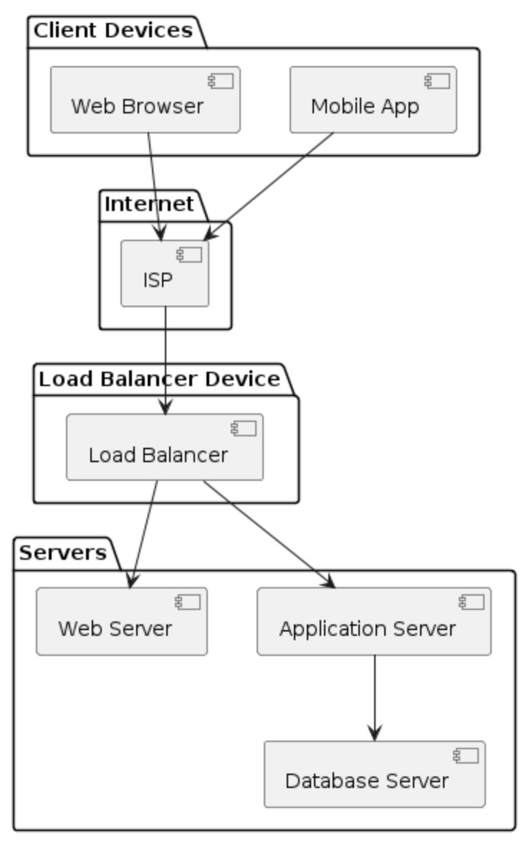

3.1 ELEMENT CATALOG OF PHYSICAL VIEWS

ID | Element | Responsibility
PV-01 | Client Devices | The devices used by clients to access the website, such as web browsers on desktops and mobile apps on smartphones or tablets.
PV-02 | ISP | The server infrastructure owned and maintained by the Internet Service Provider. This includes servers responsible for routing and managing traffic, DNS servers, authentication servers, etc.
PV-03 | Internet | Internet infrastructure that connects client devices to the servers. They interpret HTML (Hypertext Markup Language), CSS (Cascading Style Sheets), and JavaScript code to present the content, layout, and interactivity of websites to the user.
PV-04 | Load Balancer Device | Distributes incoming client requests across multiple web servers to ensure high availability and scalability. The load balancer device evenly distributes incoming network traffic, such as web requests or application requests, across multiple servers or resources.
PV-05 | Servers | The servers hosting the booking flights website. It includes web servers, application servers and database servers. Web servers handle HTTP requests, application servers execute the business logic, and database servers store and manage data. Client devices send requests to the load balancer, which then distributes them to appropriate web servers or application servers. Application servers communicate with the database server to retrieve or store data as needed. The load balancer also communicates with the Internet Service Provider (ISP) to manage incoming and outgoing traffic.

3.2 RELATIONSHIP CATALOG OF PHYSICAL VIEWS

Relationship | Responsibility
PV-01 to PV-03 | Client devices access the Internet to communicate with servers hosting the booking flights website. They interpret HTML, CSS, and JavaScript to render website content.
PV-02 to PV-03 | The ISP provides the infrastructure that forms part of the Internet. It includes servers responsible for routing and managing traffic, DNS servers, and authentication servers.
PV-03 to PV-04 | The Internet delivers incoming client requests to the load balancer device, which then distributes them across the servers hosting the booking flights website.
PV-04 to PV-05 | The load balancer device distributes incoming client requests across multiple servers to ensure high availability and scalability. It directs traffic to appropriate web servers or application servers based on predefined rules.

3.3 RATIONALE FOR PHYSICAL VIEWS

Quality attribute | ID | Quality attribute scenario | Rationale
Performance | QAR001 | The website should have fast response times, ensuring that users can search for flights, view options, and complete bookings swiftly to enhance user experience and satisfaction. | Fast response times are essential for providing a seamless user experience on the website. Users expect quick search results, browsing options, and completing bookings swiftly.
Reliability | QAR002 | The website should be available 24/7 with minimal downtime to ensure that users can access flight information and make bookings at any time without disruptions. | Continuous availability of the website is crucial for users who may need to access flight information and make bookings at any time, regardless of time zone or location. Minimal downtime ensures uninterrupted access to services, maintaining user trust and satisfaction.
Security | QAR003 | The website should employ robust security measures to protect users' personal and financial information, including secure encryption protocols for transactions and compliance with relevant data protection regulations. | Secure encryption protocols and compliance with data protection regulations help prevent fraud and ensure user privacy, fostering trust and confidence in the website.
Usability | QAR004 | The website should have a user-friendly interface with intuitive navigation, clear layout, and easy-to-use booking process, catering to users of varying technical proficiency and ensuring a smooth booking experience. | A user-friendly interface with intuitive navigation and clear layout is vital for ensuring that users of varying technical proficiency can easily navigate the website and complete bookings without confusion or frustration.
Scalability | QAR005 | The website should be able to handle a large number of concurrent users during peak times without performance degradation or system crashes, ensuring consistent availability and responsiveness. | The ability to handle many concurrent users during peak times without performance degradation or system crashes is critical for maintaining consistent availability and responsiveness.
Compatibility | QAR006 | The website should be compatible with major web browsers (e.g., Chrome, Firefox, Safari) and devices (e.g., desktops, tablets, smartphones), ensuring a consistent experience across different platforms. | Compatibility with major web browsers and devices ensures that users can access the website seamlessly from different platforms without encountering compatibility issues.
Performance | QAR007 | The website should have optimized load times for pages and content, minimizing waiting times for users and improving overall user satisfaction and engagement system from different platforms. | Optimized load times for pages and content are essential for minimizing waiting times and keeping users engaged on the website. Fast loading speeds improve user satisfaction and increase the likelihood of user interaction and conversion.
Flexibility | QAR008 | The website should offer customization options for users, such as filters for search results and personalized notifications, enhancing user control and satisfaction. | Offering customization options for users to tailor their experience to their preferences and needs.
Reliability | QAR009 | The website should ensure transaction integrity, including accurate booking information and reliable payment processing, to instill trust and confidence in users. | Ensuring transaction integrity, including accurate booking information and reliable payment processing.Reliable transactions build credibility and encourage users to complete bookings without hesitation.
Performance | QAR010 | The website's search functionality should be fast and efficient, allowing users to quickly find relevant flight options based on their preferences, dates, and destinations, enhancing user satisfaction and conversion rates. | Fast and efficient search functionality is essential for users to quickly find relevant flight options based on their preferences. A responsive search feature enhances user satisfaction and increases the likelihood of successful bookings.
Accuracy | QAR011 | The website should ensure the accuracy and reliability of flight information, including schedules, availability, and pricing, by integrating with reliable data sources and updating information in real-time, avoiding confusion and disappointment for users. | Ensuring the accuracy and reliability of flight information for avoiding confusion and disappointment among users. Integration with reliable data sources and real-time updates help maintain accurate and up-to-date information, enhancing user trust and satisfaction.

V. Software Architecture

MODULE VIEWS

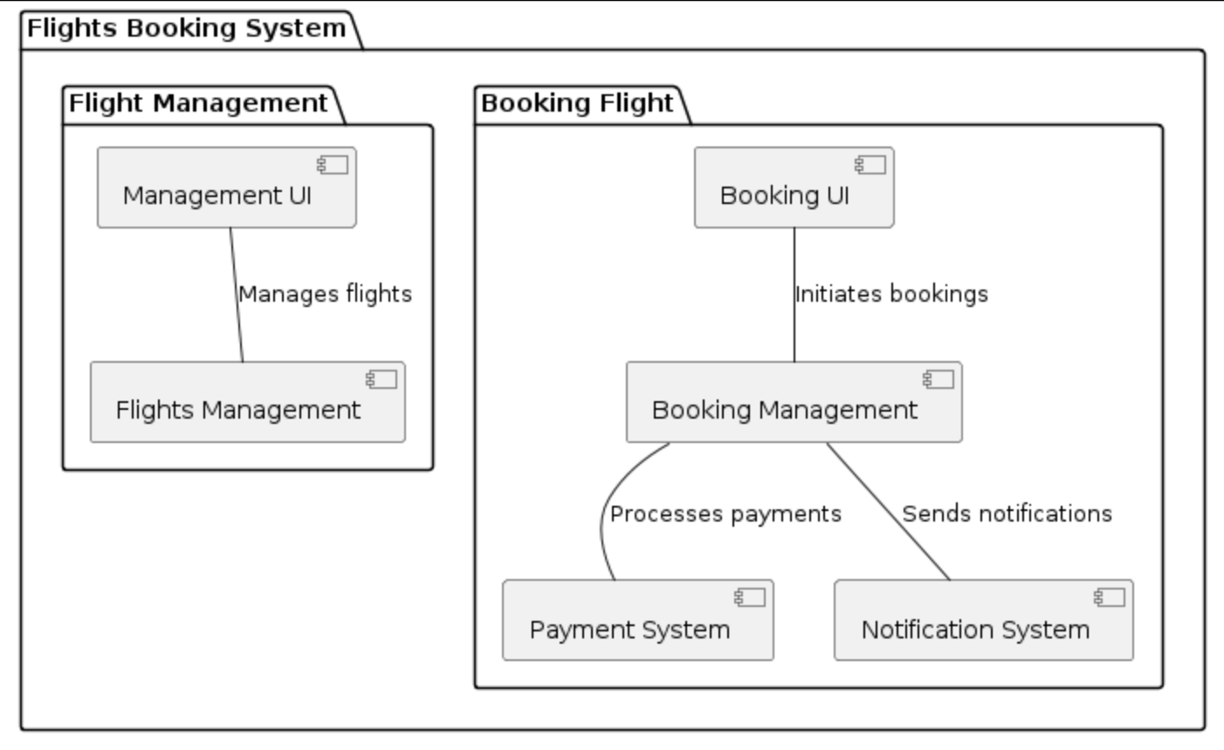

Module: Management UI


Module: Management UI
Responsibility: Responsible for providing a user interface for managing flights. It allows administrators to view, add, update and delete flight information.

Module: Flights Management


Module: Flights Management
Responsibility: Responsible for handling operations related to flights such as retrieving flight schedules, managing seat availability, prices and updating flight information in the database.

Module: Booking UI


Module: Booking UI
Responsibility: Responsible for providing a user interface for booking flights. It allows users to search for flights, their information and managing bookings.

Module: Booking Management


Module: Booking Management
Responsibility: Responsible for managing the booking process. It includes functionalities such as validating booking requests, checking seat availability, confirming bookings, updaing booking status and handling cancellations.

Module: Payment System
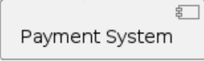

Module: Payment System
Responsibility: Responsible for processing payments for flight bookings. It securely manages payment information, validates payment details, processes transactions and provides confirmation of successful payments.

Module: Notification System
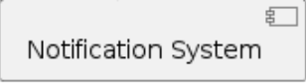

Module: Notification System
Responsibility: Responsible for sending notifications to users. It notifies users about booking confirmations, updates, cancellations, or any other relevant information regarding their bookings.

C&C (Component & Connector) VIEWS

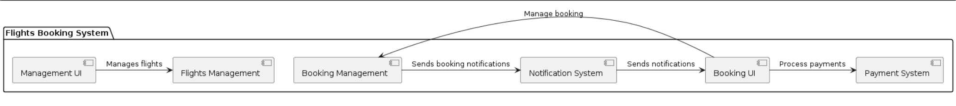

Management UI:
- Manages flights: Responsible for managing the overall operation of the system, including user authentication, system configuration and administrative tasks.

Flight Management:
- Manages: Handles the management of flights, including adding, editing and removing their details.

Booking UI:
- Manages booking: Provides functionality for users to manage their bookings, including booking and canceling reservations.
- Processes payments: Handles payment transactions securely and efficiently, ensuring successful completion of booking transactions.

Booking Management:
- Manages bookings: Manages the booking process, including handling booking requests, confirming reservations and updating booking status.
- Sends booking notifications: After successfully booking a flight, show notifications to users.

Payment Processing:
- Processes payments: Handles payment transactions securely and efficiently, ensuring successful completion of booking transactions.

Notification System:
- Sends notifications: Sends notifications to users, manager and admin, including booking confirmations, reminders, and updates.

ALLOCATION VIEWS

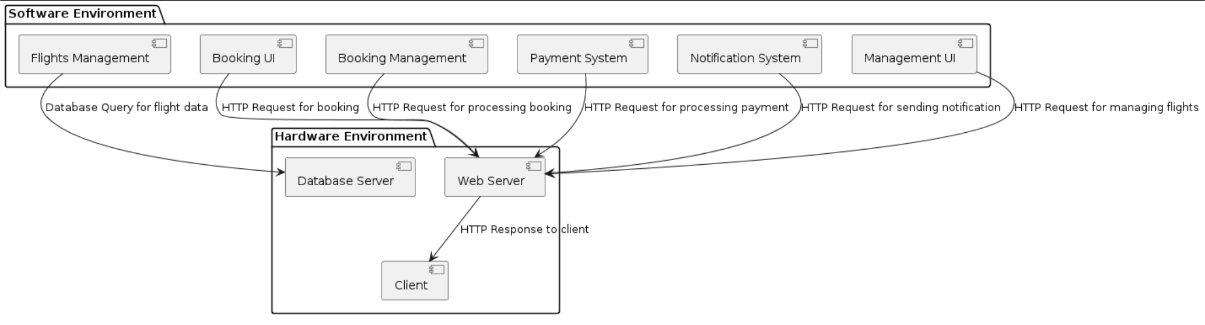

Software Environment:

Management UI:
- Responsibility: Provides a user interface for managing flights. Allows administrators to view, add, update, and delete flight information.
- Workflow: Accepts user input for flight management operations. Sends HTTP requests to the web server containing the required data and operation type.

Flight Management:
- Responsibility: Manages flight-related operations such as retrieving flight schedules, checking seat availability, and updating flight information in the database.
- Workflow: Receives HTTP requests from the web server for flight-related data. Queries the database server for flight information and processes the requested operations.

Booking UI:
- Responsibility: Provides a user interface for booking flights. Allows users to search for flights, booking flights and canceling flights.
- Workflow: Accepts user input for booking operations. Sends HTTP requests to the web server containing booking details and operation type.

Booking Manangement:
- Responsibility: Manages the booking process, including validating booking requests, confirming bookings and handling cancellations.
- Workflow: Receives HTTP requests from the web server for booking-related operations. Processes the requests by interacting with the database server and sends back the appropriate response.

Payment System:
- Responsibility: Handles payment transactions for bookings.
- Workflow: Receives HTTP requests from the web server for payment processing. Validates payment details, interacts with external payment gateways or services, and sends back the payment status to the web server.

Notification System:
- Responsibility: Sends notifications to users and administrators.
- Workflow: Receives HTTP requests from the web server for sending notifications. Processes the requests and sends notifications to users via email, SMS, or other communication channels.

Hardware Environment:

Web Server:
  - Responsibility: Acts as an intermediary between the client-side components and the server-side components of the system. Handles HTTP requests and responses.
  - Workflow: Receives HTTP requests from users and forwards them to the respective software modules for processing.

Database Server:
- Responsibility: Stores and manages the system's data.
- Workflow: Executes database operations like queries and updates requested by the software modules, ensuring data integrity and persistence.

Client:
- Responsibility: Represents the user interface through which users interact with the system. It can be a web browser or a mobile application.
- Workflow: Sends HTTP requests to the Web Server for various operations such as managing flights, booking flights, processing payments, and sending notifications. Displays the received HTTP responses to the user. Provides a user-friendly interface for users to interact with the system by entering input and viewing results. Handles user interactions and sends corresponding requests to the Web Server.

Workflows:
- Users interact with the system through the Booking UI and Management UI, sending HTTP requests.
- The software modules process these requests, perform necessary operations, and interact with the database server to retrieve or store data.
- System validates information, checks seat availability. System processes the booking request, updates the database records, and reserves the selected seats.
- System securely processes the payment transaction using the Payment System component.
- Notifications are triggered by various events and sent out by the Notification System.

VI. SOFTWARE DESIGN

Methodology
- By integrating Top-Down and Bottom-Up methodologies for this system, it’s leveraging the strengths of both approaches to achieve a comprehensive understanding and effective implementation. While top-down approaches offer strategic clarity and goal alignment, bottom-up methodologies provide granular insights and detailed execution plans.
- The top-down approach sets the overarching direction and goals of the project. This involves defining the project's objectives, scope, and deliverables, often driven by executive leadership or key stakeholders. Top-down planning provides clarity of purpose, ensuring that all project activities are aligned with the organization's strategic priorities. Moreover, it facilitates effective resource allocation, as decision-makers can prioritize initiatives based on their strategic importance and potential impact.
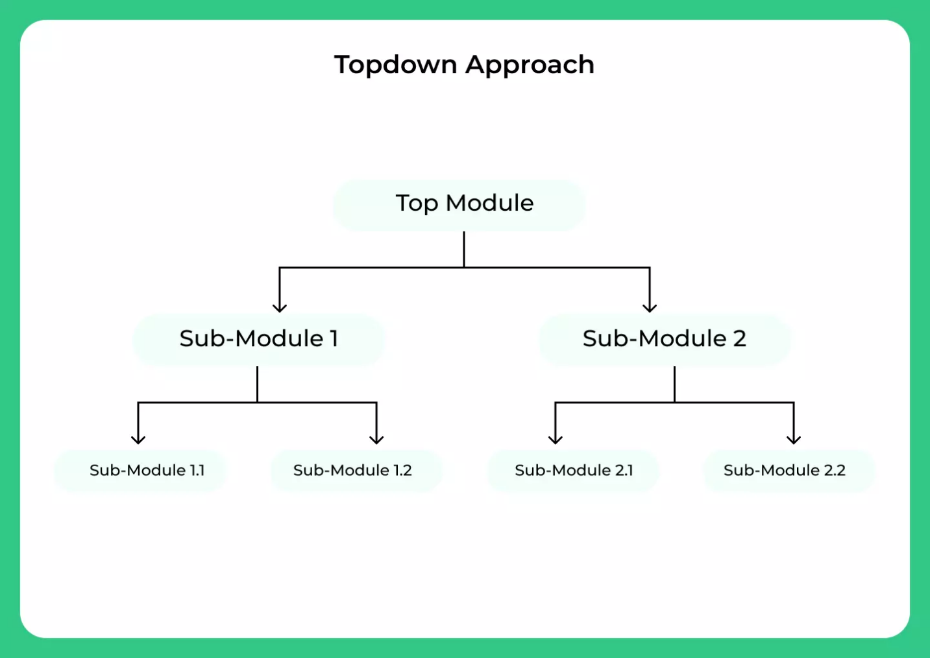
- The bottom-up approach delves into the details of implementation, breaking down the project into smaller tasks or components. This phase involves thorough analysis, design, and execution planning, where project teams collaborate to develop actionable plans for achieving the project objectives. Bottom-up methodologies empower frontline workers and subject matter experts to contribute their expertise, leading to more robust and realistic project plans.
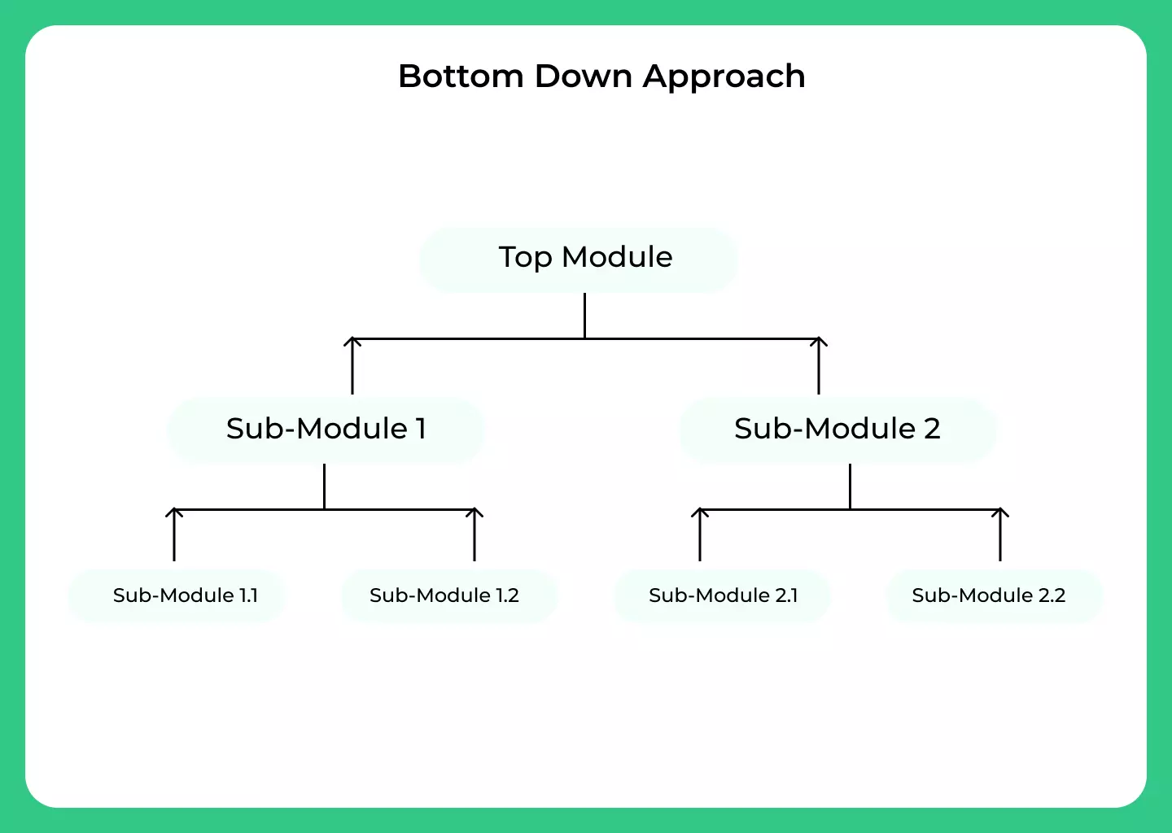
- The integration of top-down and bottom-up methodologies entails a dynamic and iterative process that unfolds across multiple stages of the project lifecycle. At the outset, top-down planning sets the strategic direction, guiding the initial scoping and resource allocation decisions. However, as the project progresses, bottom-up analysis comes into play, informing the detailed design and execution of individual project components. From now on, in short, we’ll call it Hybrid (Combination of Top-Down and Bottom-Up methodologies).
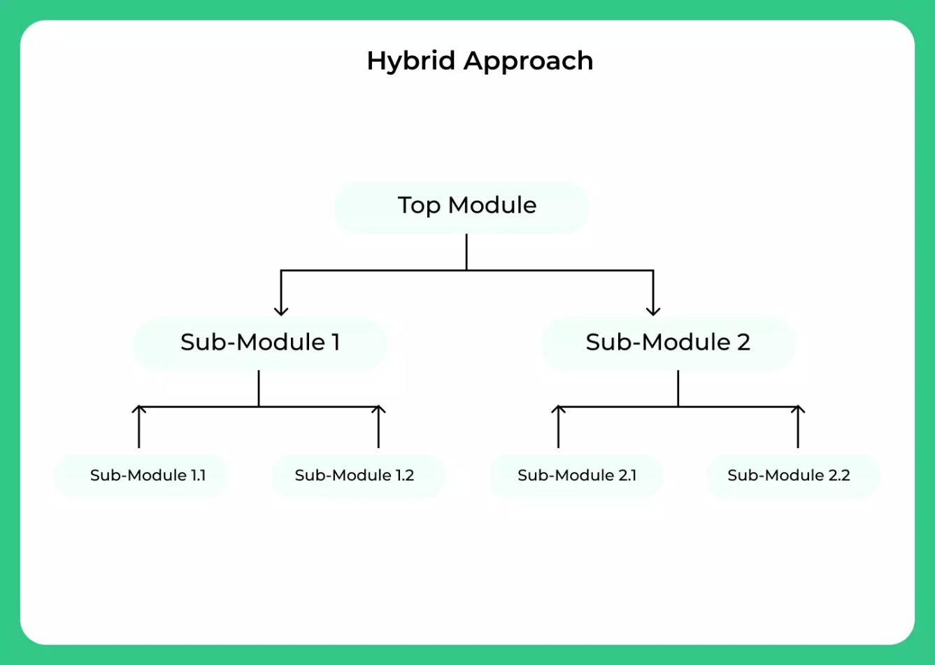

Method
- Establishing Strategic Vision: The strategic vision of the website is the foundational step. This involves understanding the market, identifying target audiences, and defining key objectives. Here, a top-down approach helps in setting overarching goals while bottom-up analysis dives into specific customer needs and industry trends.
- Conducting Market Analysis: Leveraging Hybrid thorough market analysis is conducted. Top-down insights provide a macro perspective on industry trends, competitor analysis, and market demands. Bottom-up analysis delves into specific user preferences, pain points, and emerging patterns, ensuring alignment with strategic goals.
- Designing User-Centric Features: Using Agile principles. Specific are iterative prototyping and user testing, the development team collaborates to translate strategic objectives into actionable designs. Continuous feedback loops ensure alignment with both top-down strategic vision and bottom-up user requirements.

Process
- Implementing Agile Development: Adopting Agile methodologies. Specificly, Scrum, the development process is structured into iterative sprints. This approach allows for the incremental development of the flight booking website, with each sprint delivering tangible value to users. Agile principles promote adaptability, collaboration and responsiveness to changing market dynamics.
- Continuous Monitoring and Optimization: Post-launch, the method and process extend to continuous monitoring and optimization. Utilizing performance metrics, user analytics and feedback mechanisms, the website is continually evaluated against strategic objectives and user expectations.
- Agile retrospectives facilitate iterative improvements, ensuring the website remains aligned with evolving market needs.
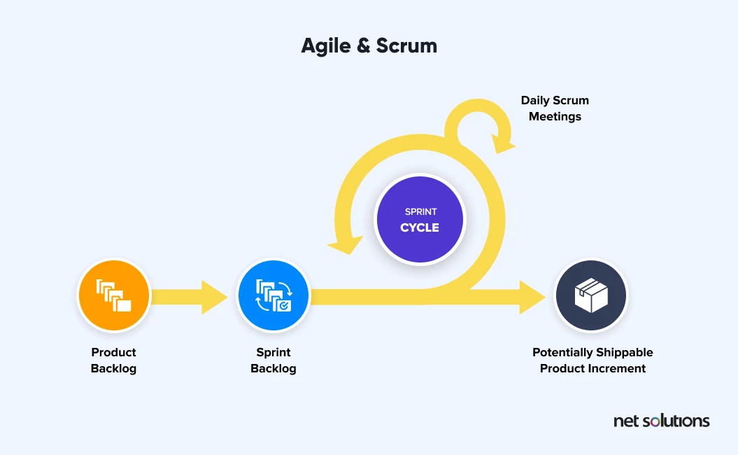

Detail Design

Login/Signup
* SD Login/SignUp:
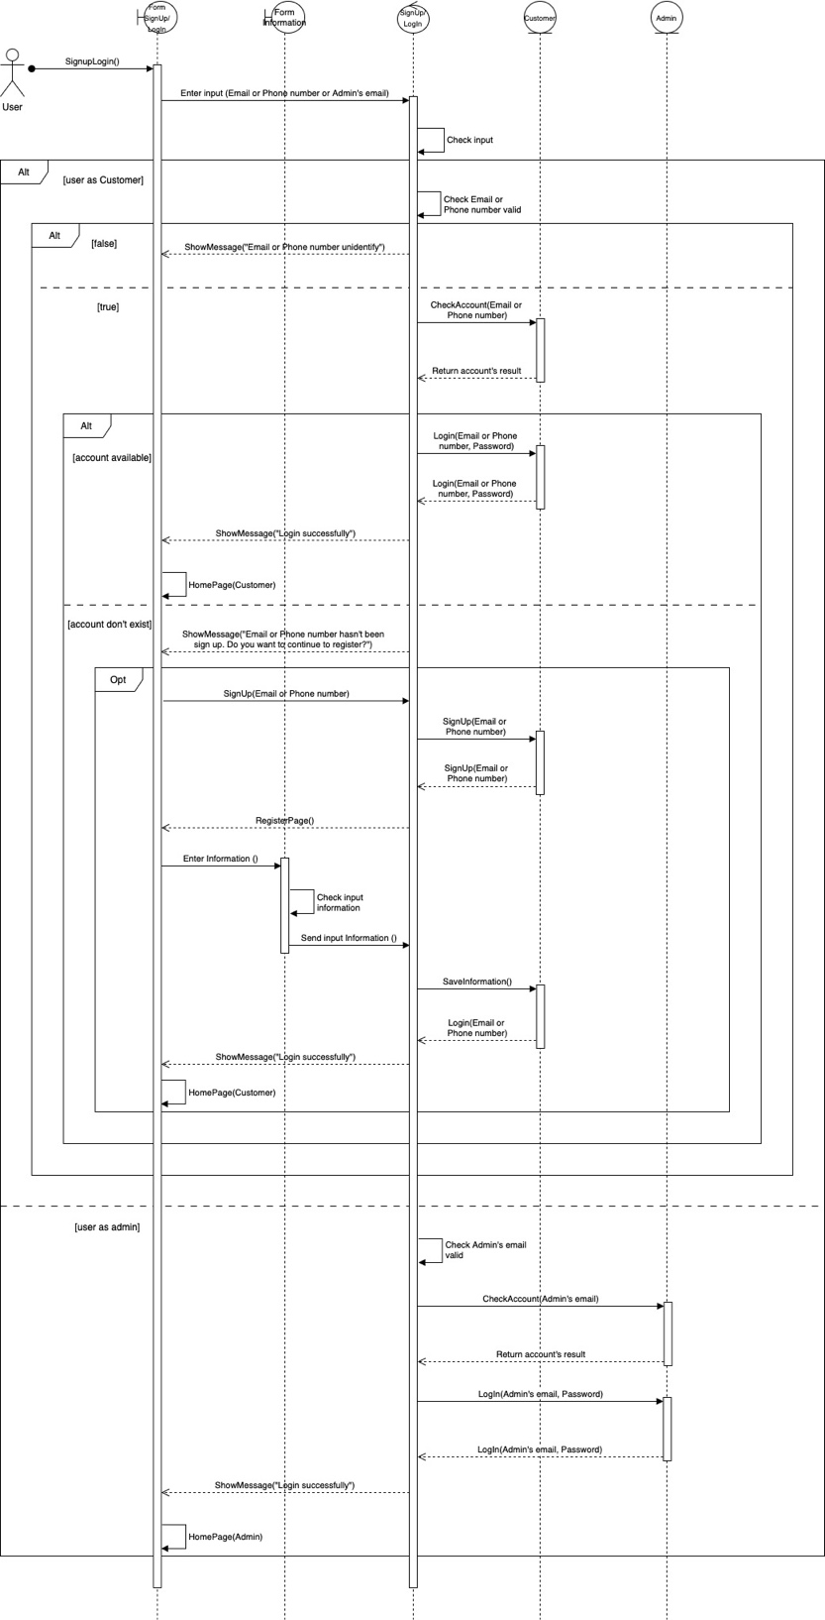

Change Account Information, Change Password
* SD Change Account Information:
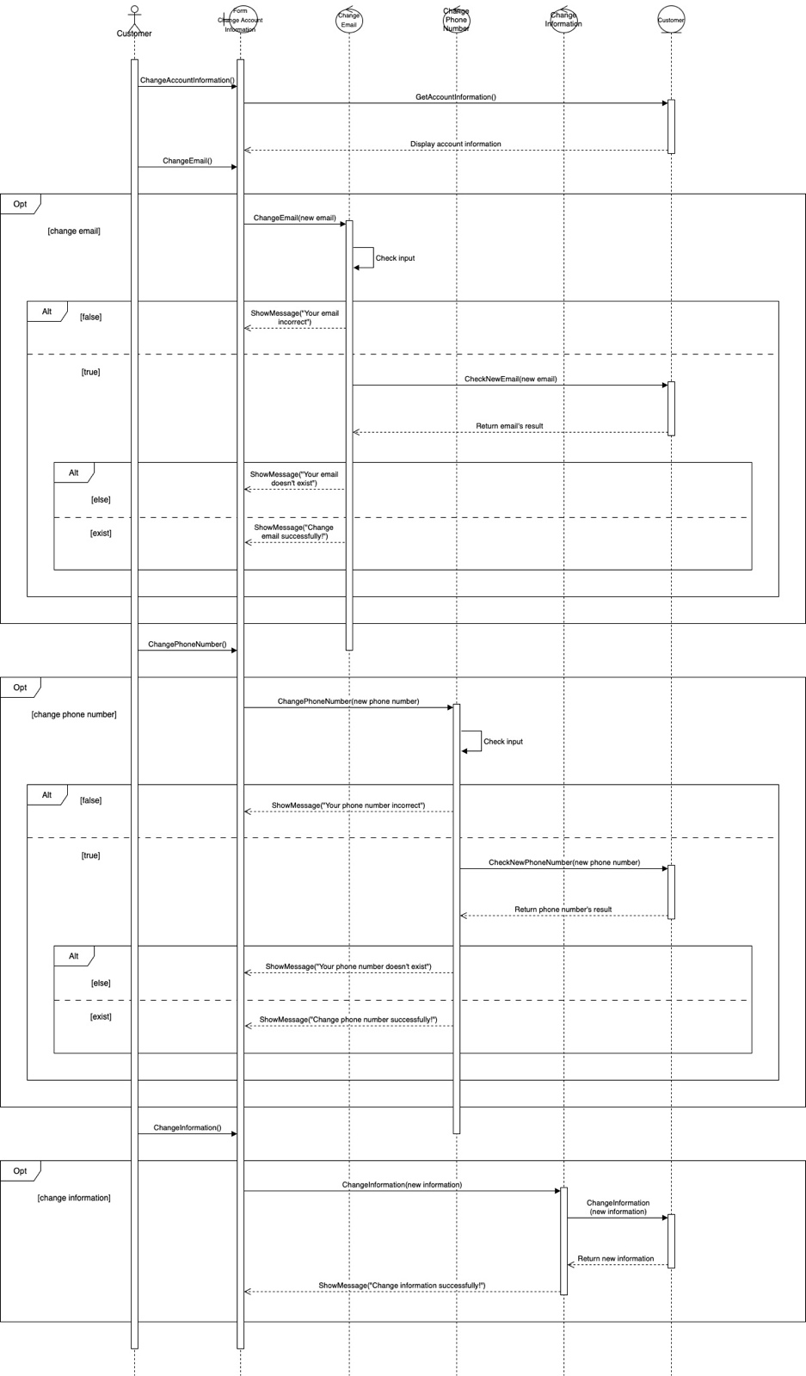

* SD Change Password:
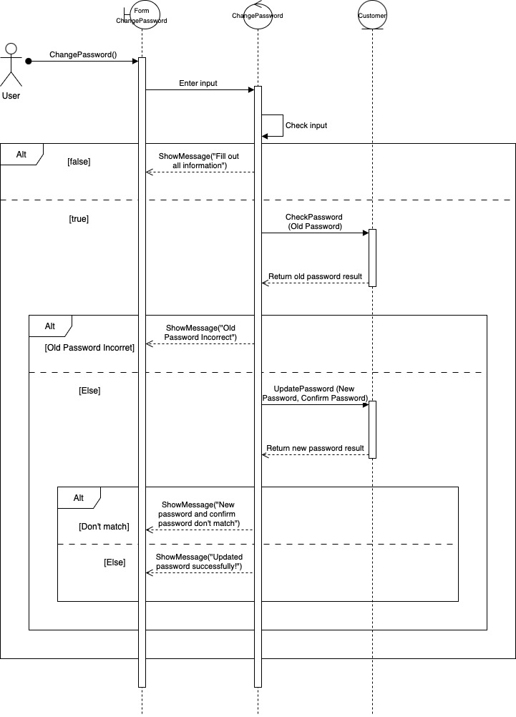

Search, Booking, Payment, History Booked & Refund Flight
* SD Search:
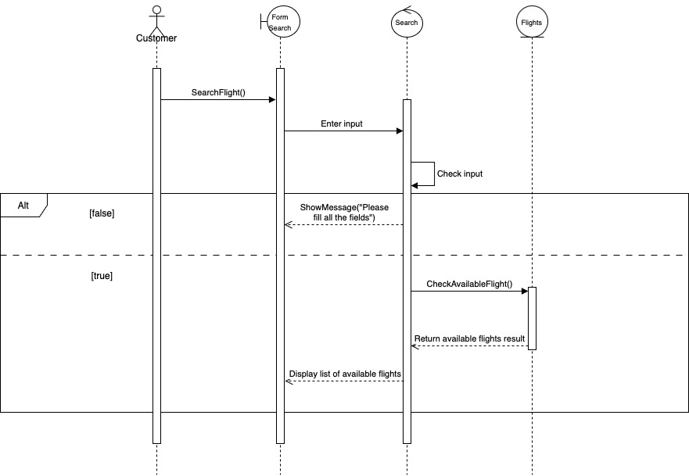

* SD Booking:
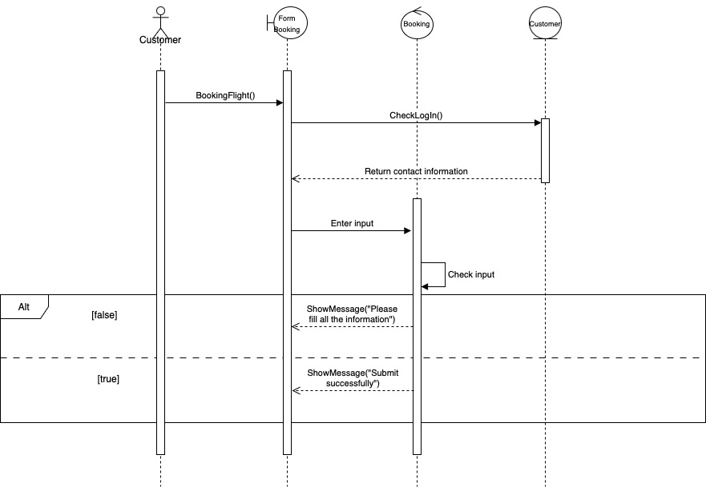
* SD Payment:
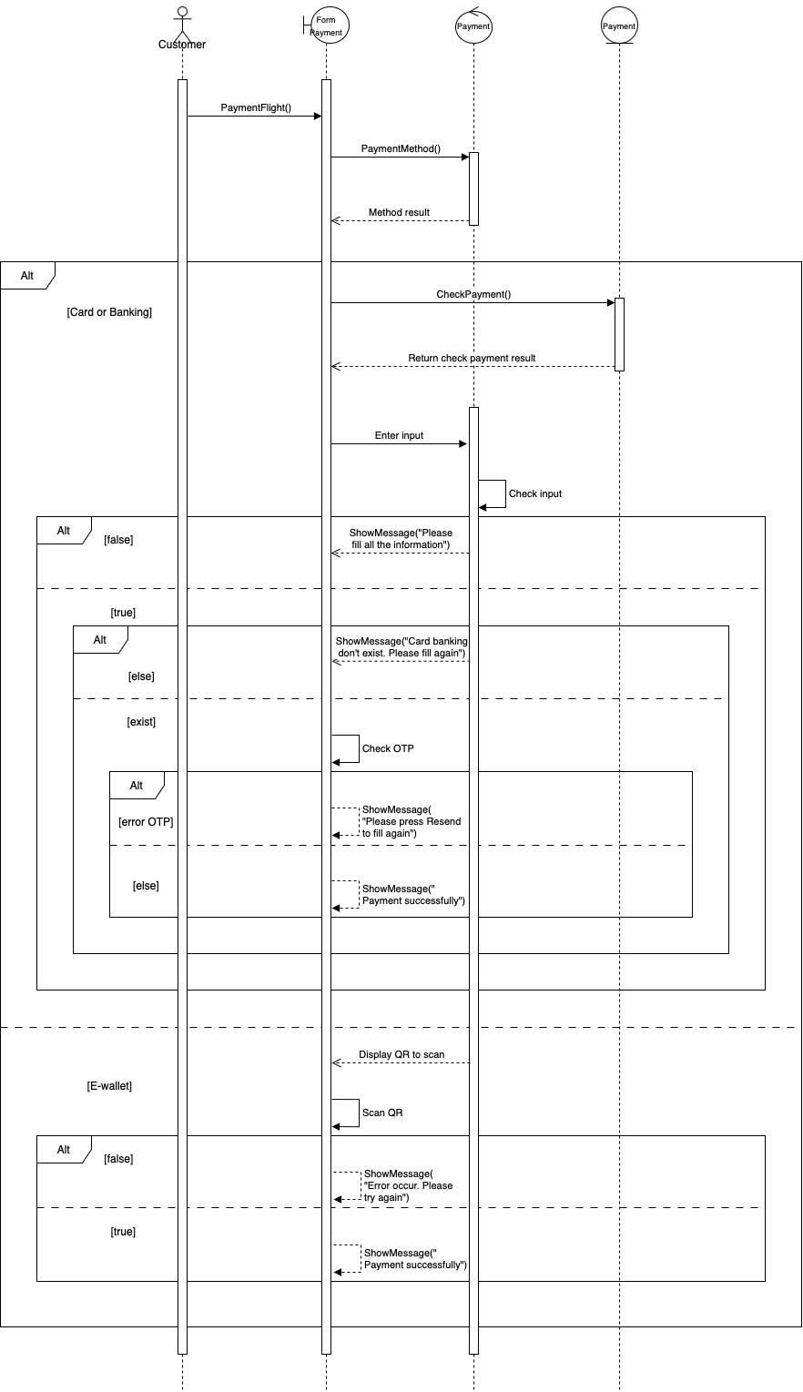
* SD History Booked & Refund:
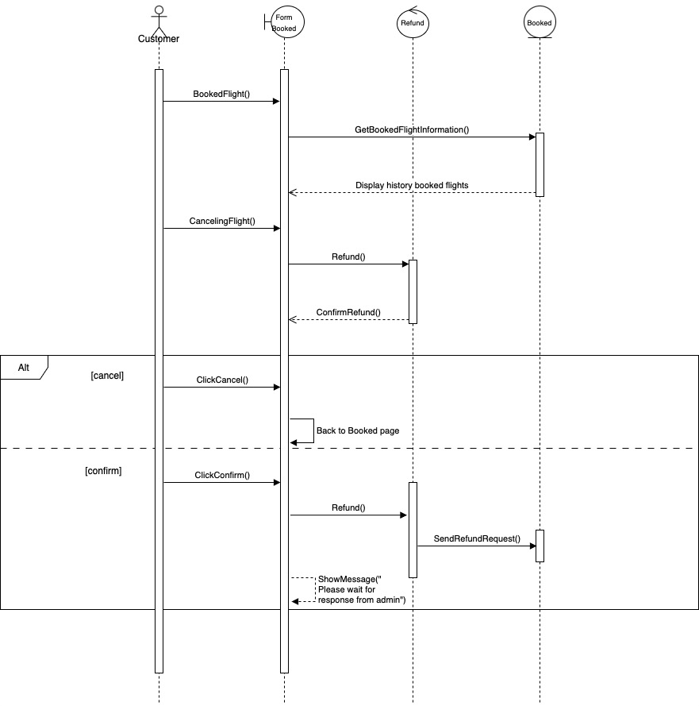

Manage Flights
* Add:
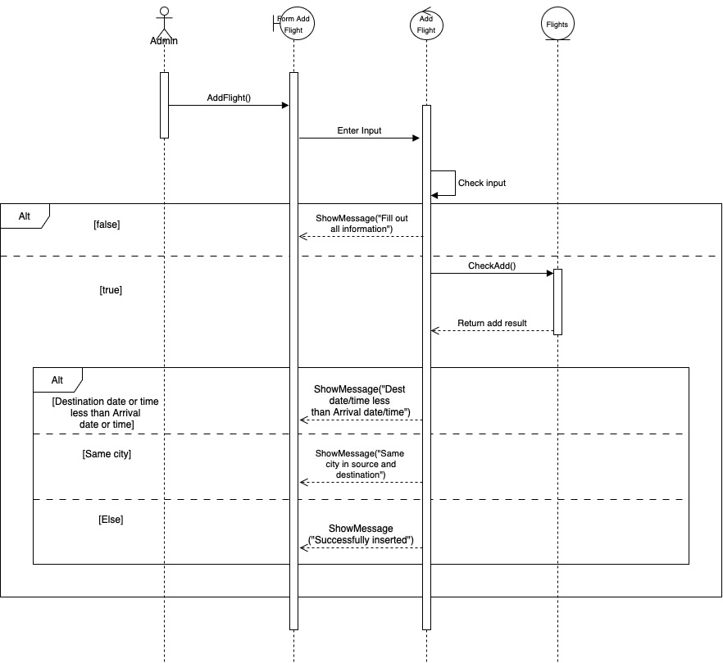

* Update:
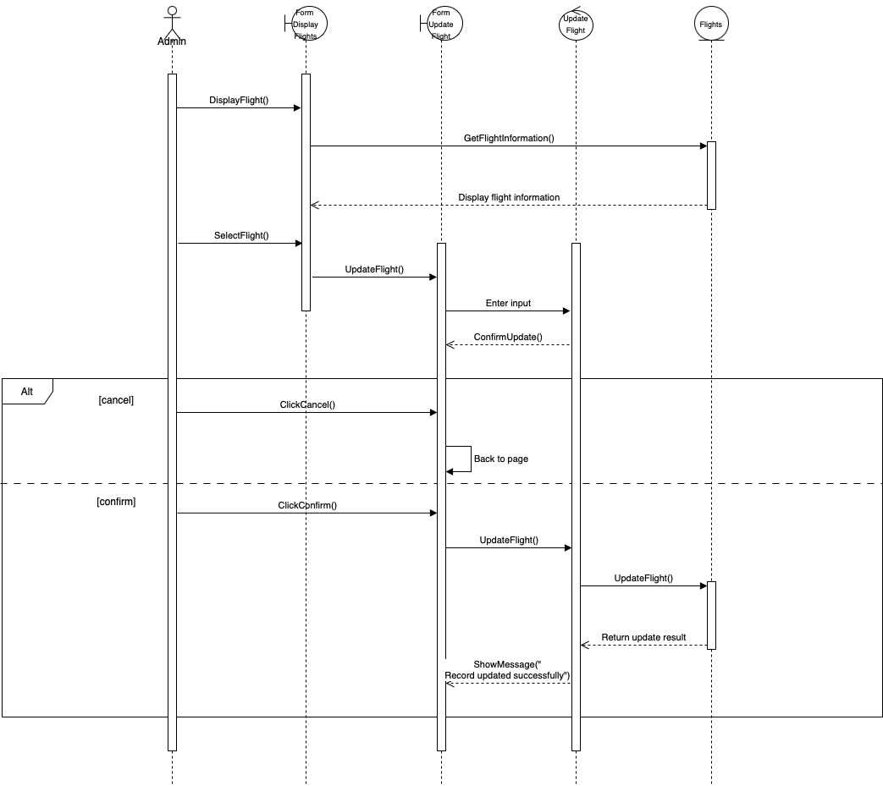

* Delete:
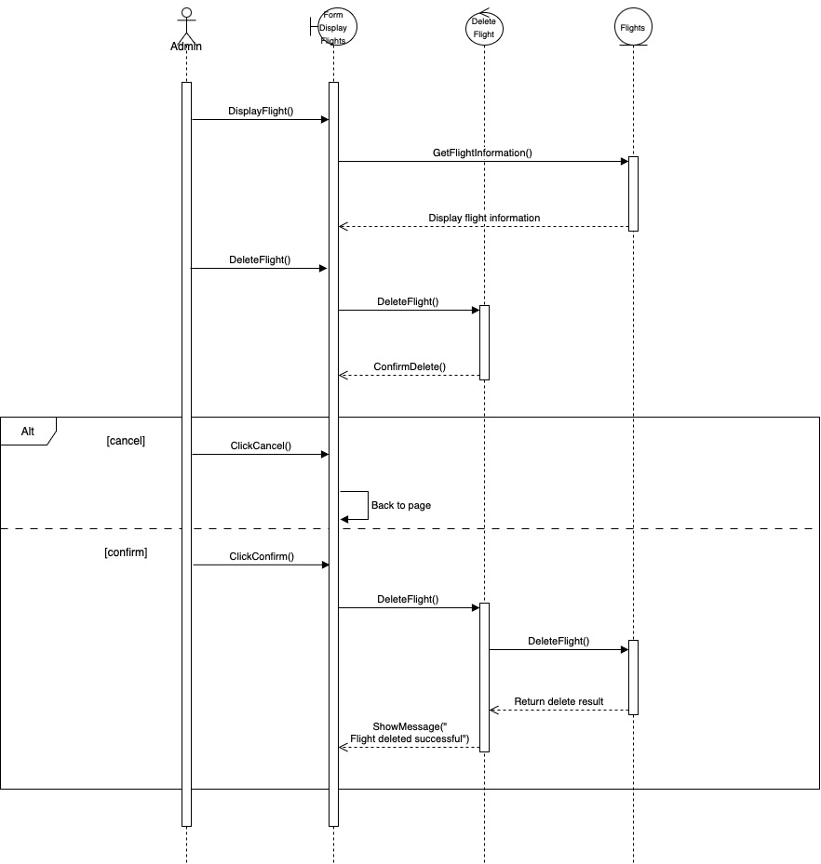

Manage Airlines
* Add:
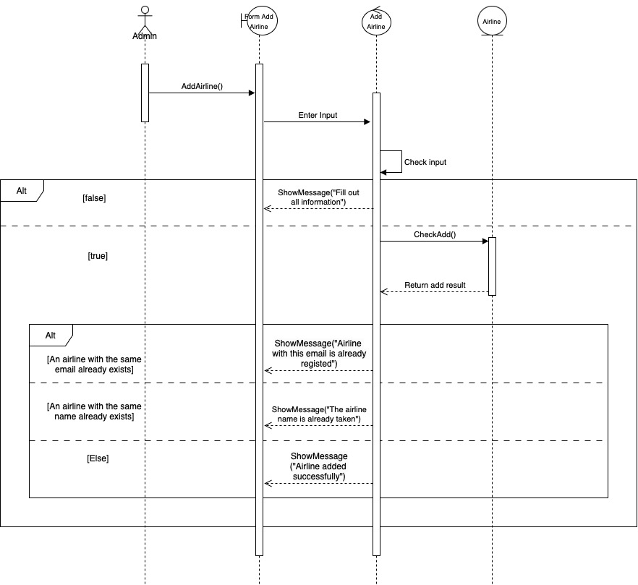

* Delete:
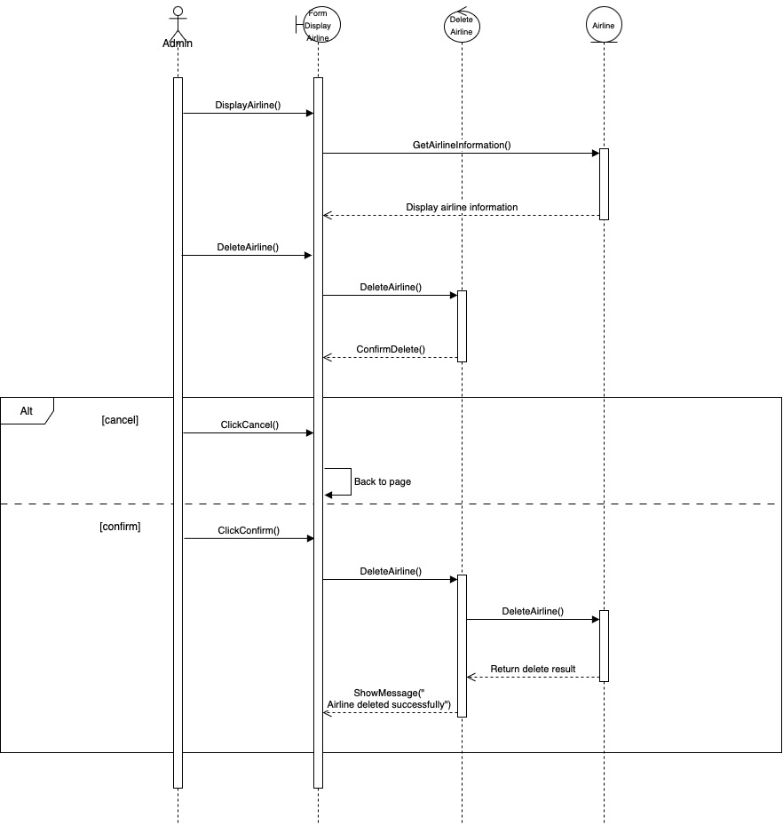

* Update:
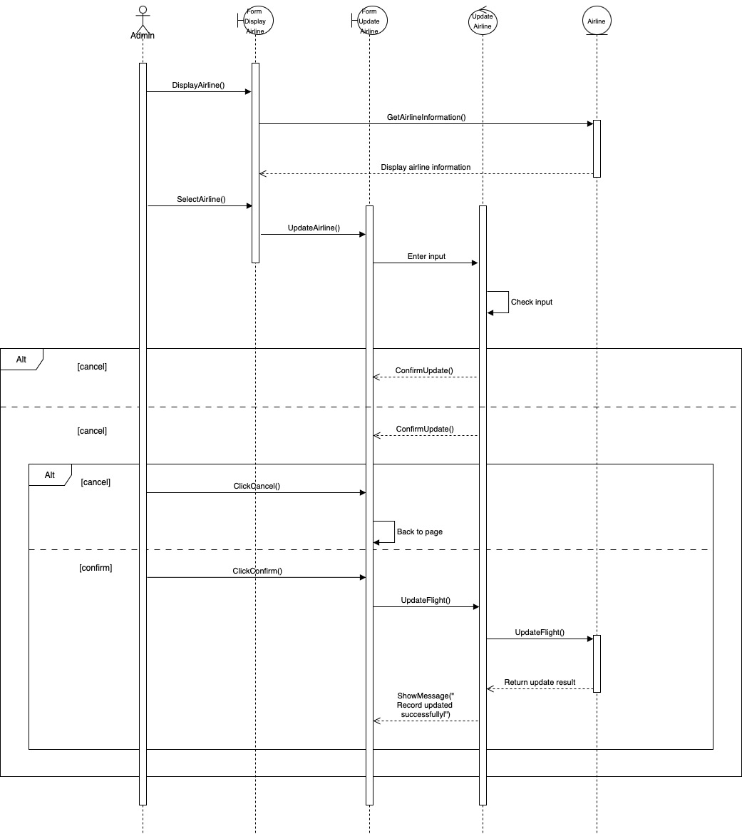

Manage Booked Flights
* Deleted Booked Flights:
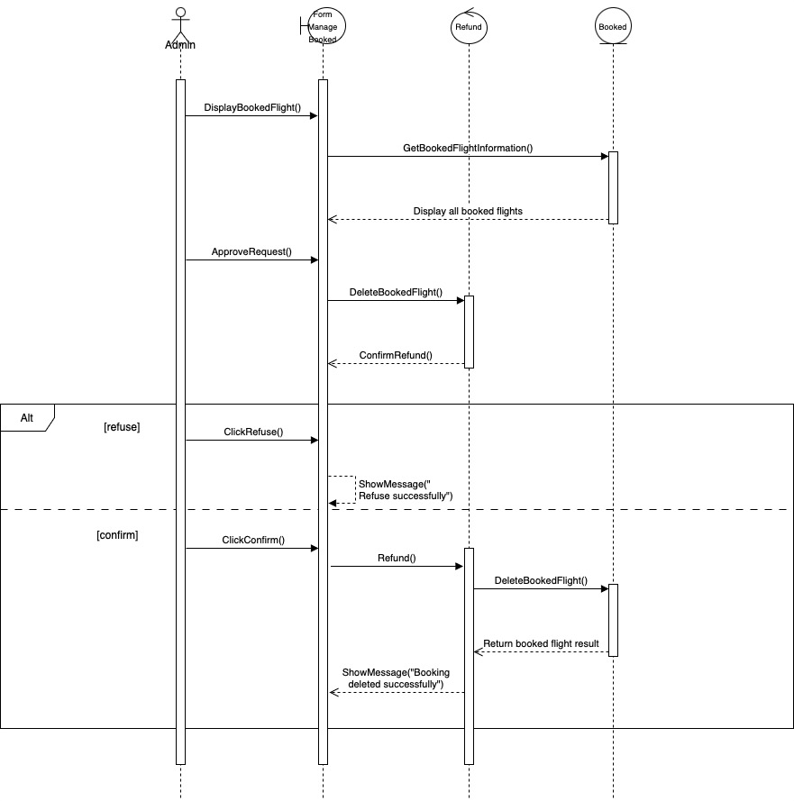

System Design:

Customer system
* SSD Customer:
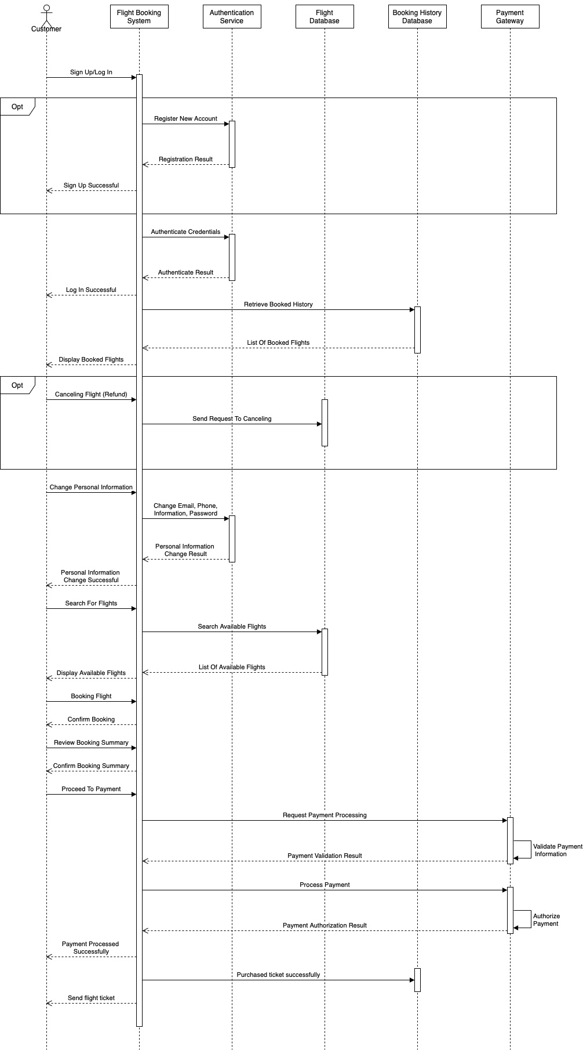

Admin system
* SSD Admin:
